# 3D Printing Summary

|  |  |
| --- | --- |
| **Metrics** | **\*Configuration 1\*** |
| Total Print Time (min) | Dependent on STL dimensions |
| Total Number of Components | 1 |
| Typical Total Mass (g) | 100 |
| Typical Number of Print Setups | 1 |

**Specifications**

Input the desired dimensions into OpenSCAD based on the cup and cup holder dimensions. Note that there are four radii and one height measurement. When measuring the radius, ensure the cup measurements line up with the height on the cup that should sit in the cup holder.

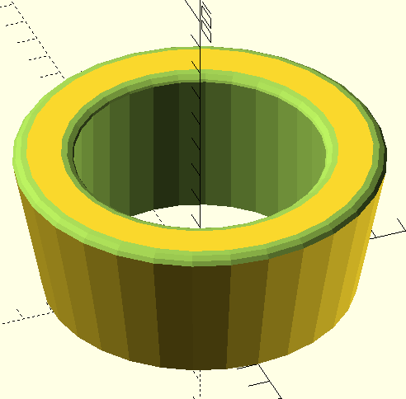

Height

Lower Holder Diameter

Lower Cup Diameter

Upper Holder Diameter

Upper Cup Diameter

|  |  |  |  |
| --- | --- | --- | --- |
| Cup Holder | Lower Diameter [mm] | Upper Diameter [mm] | Height [mm] |
| [Cup Holder for Walker](https://makersmakingchange.com/assistive-devices/?_sf_s=cup%20holder) | 78 | 81 | 64 |
| [Swivel Wheelchair Cup Holder](https://makersmakingchange.com/project/swivel-wheelchair-cup-holder/) | 74 | 74 | 85 |
| [Universal Travel Coffee Gimbal](https://makersmakingchange.com/project/universal-travel-coffee-gimbal/) | 78 | 84 | 24 |

# 3D Printing Settings

|  |  |  |  |  |  |  |  |
| --- | --- | --- | --- | --- | --- | --- | --- |
| **Print File Name** | **Qty** | **Total Print Time (hr:min)** | **Mass (g)** | **Infill (%)** | **Support** | **Layer Height/ Nozzle Diameter(mm)** | **Notes** |
| Cup_Ring_v0.2.stl | 1 | Dependent on STL dimensions. Likely 1 hour minimum | Dependent on STL dimensions. | 5 | N | 0.2/0.4 | Print in given orientation. |

# Post-Processing

* Clean any stringing or filament strands from the print.

# Customization Options

* Ask the user if they have any colour preferences.
* Ask the user for the required dimensions to customize the STL appropriately to fit both their cup holder and beverage container.

# Examples of Quality Prints:

**Photos of Component 1:**

